

# 

### Semester Two Examination, 2018

### Question/Answer booklet

# MATHEMATICS

**SOLUTIONS**

**APPLICATIONS**

**UNITS 3 AND 4**

## Section Two:

## Calculator-assumed

|  |  |  |  |  |  |  |  |  |  |  |
| --- | --- | --- | --- | --- | --- | --- | --- | --- | --- | --- |
| Student number: In figures |  |  |  |  |  |  |  |  |  |  |

In words

Your name

## Time allowed for this section

Reading time before commencing work: ten minutes

Working time: one hundred minutes

## Materials required/recommended for this section

***To be provided by the supervisor***

This Question/Answer booklet

Formula sheet (retained from Section One)

***To be provided by the candidate***

Standard items: pens (blue/black preferred), pencils (including coloured), sharpener,  
correction fluid/tape, eraser, ruler, highlighters

Special items: drawing instruments, templates, notes on two unfolded sheets of A4 paper, and up to three calculators approved for use in this examination

## Important note to candidates

No other items may be taken into the examination room. It is **your** responsibility to ensure that you do not have any unauthorised material. If you have any unauthorised material with you, hand it to the supervisor **before** reading any further.

## Structure of this paper

|  |  |  |  |  |  |
| --- | --- | --- | --- | --- | --- |
| Section | Number of questions available | Number of questions to be answered | Working  time (minutes) | Marks available | Percentage of examination |
| Section One:  Calculator-free | 7 | 7 | 50 | 51 | 35 |
| Section Two:  Calculator-assumed | 12 | 12 | 100 | 99 | 65 |
|  | | |  | **Total** | 100 |

## Instructions to candidates

1. The rules for the conduct of examinations are detailed in the school handbook. Sitting this examination implies that you agree to abide by these rules.

2. Write your answers in this Question/Answer booklet.

3. You must be careful to confine your response to the specific question asked and to follow any instructions that are specified to a particular question.

4. Supplementary pages for the use of planning/continuing your answer to a question  
have been provided at the end of this Question/Answer booklet. If you use these pages to continue an answer, indicate at the original answer where the answer is continued, i.e. give the page number.

5. Show all your working clearly. Your working should be in sufficient detail to allow your answers to be checked readily and for marks to be awarded for reasoning. Incorrect answers given without supporting reasoning cannot be allocated any marks. For any question or part question worth more than two marks, valid working or justification is required to receive full marks. If you repeat any question, ensure that you cancel the answer you do not wish to have marked.

6. It is recommended that you do not use pencil, except in diagrams.

7. The Formula sheet is not to be handed in with your Question/Answer booklet.

Section Two: Calculator-assumed 65% (99 Marks)

This section has**twelve (****12)** questions. Answer **all** questions. Write your answers in the spaces provided.

Working time: 100 minutes.

Question 8 (6 marks)

The deseasonalised number of working holiday makers in Australia over the four-year period from March 2014 to December 2017 was modelled by , where is the number of people in thousands and is the quarter, with corresponding to March 2014.

The Seasonal Index table is shown below.

|  |  |  |  |  |
| --- | --- | --- | --- | --- |
| Quarter | March | June | September | December |
| Seasonal Index |  |  |  |  |

(a) Determine the value of in the table above. (1 mark)

|  |
| --- |
| **Solution** |
|  |
| **Specific behaviours** |
| ✓ correct value |

(b) State, with reasons, whether the number of working holiday makers in Australia was highest during September 2017 or during September 2014. (2 marks)

|  |
| --- |
| **Solution** |
| Sept 2014, as the gradient of the linear model is , indicating a decrease of 1382 people per quarter. |
| **Specific behaviours** |
| ✓ chooses correct year  ✓ indicates gradient implies decrease over time |

(c) Use your knowledge of time series to estimate the actual change in the number of working holiday makers in Australia from December 2017 ( to March 2018 (.

(3 marks)

|  |
| --- |
| **Solution** |
|  |
| **Specific behaviours** |
| ✓ correct prediction for in 's  ✓ correct prediction for in 's  ✓ correct change, adjusting for 's |

Question 9 (6 marks)

(a) A connected planar graph has faces and vertices. Determine how many edges must be removed from the graph to leave the minimum spanning tree. (3 marks)

|  |
| --- |
| **Solution** |
| Hence 10 edges must be removed. |
| **Specific behaviours** |
| ✓ indicates edges in graph  ✓ indicates edges in MST  ✓ states difference |

(b) The vertices in the graph below represent activity centres in a theme park and the edges represent various footpaths between the centres. The weights on the edges represent the time to travel along that footpath. Identify the minimum spanning tree on the graph and state its length. (3 marks)

|  |
| --- |
| **Solution** |
|  |
| **Specific behaviours** |
| ✓ tree with 7 edges  ✓ correct MST highlighted/shown  ✓ correct length |

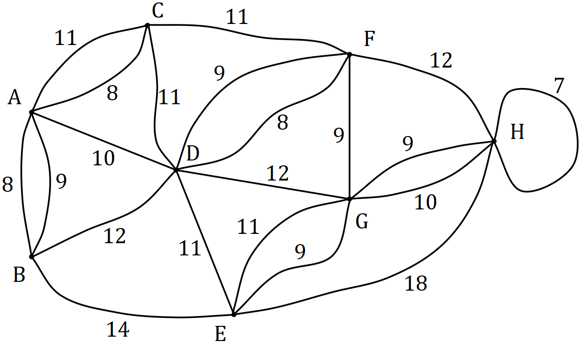

Question 10 (8 marks)

The data in the table below was collected by a student who was investigating whether an association exists between a person's hair and eye colour. The observations were taken from a survey of people.

|  |  |  |  |
| --- | --- | --- | --- |
|  |  | Eye colour | |
|  |  | Blue-Green | Brown |
| Hair colour | Black |  |  |
| Blond |  |  |
| Brown |  |  |

(a) What percentage of the people surveyed had brown eyes? (1 mark)

|  |
| --- |
| **Solution** |
|  |
| **Specific behaviours** |
| ✓ correct percentage |

(b) What percentage of the brown eyed people had blond hair? (1 mark)

|  |
| --- |
| **Solution** |
|  |
| **Specific behaviours** |
| ✓ correct percentage |

(c) Complete the table of **column** percentages below. (2 marks)

|  |
| --- |
| **Solution** |
| See table |
| **Specific behaviours** |
| ✓ one column correct  ✓ both columns correct |

|  |  |  |  |
| --- | --- | --- | --- |
|  |  | Eye colour | |
|  | % | Blue-Green | Brown |
| Hair colour | Black |  |  |
| Blond |  |  |
| Brown |  |  |

(d) Does the data suggest the presence of an association between the categorical variables? Justify your answer using figures from the percentage table. (2 marks)

|  |
| --- |
| **Solution** |
| Yes, as the two percentages in each row are quite different. For example, 45% of brown eyed people have brown hair but only 20% of those with blue-green eyes have brown hair. |
| **Specific behaviours** |
| ✓ yes to association  ✓ uses appropriate percentages to justify |

(e) One of the conclusions made by the student was that having black hair caused a person to have brown eyes. Comment on this conclusion. (2 marks)

|  |
| --- |
| **Solution** |
| This conclusion is not valid. An observed association does not mean there is a causal relationship between the variables. |
| **Specific behaviours** |
| ✓ indicates conclusion not valid  ✓ comments on causality |

Question 11 (6 marks)

Spectators leave a sports ground and walk to a train station along footpaths in the directions shown on the network below. The weights on the edges represent the maximum number of people who can safely travel along each footpath, in hundreds of people per minute.

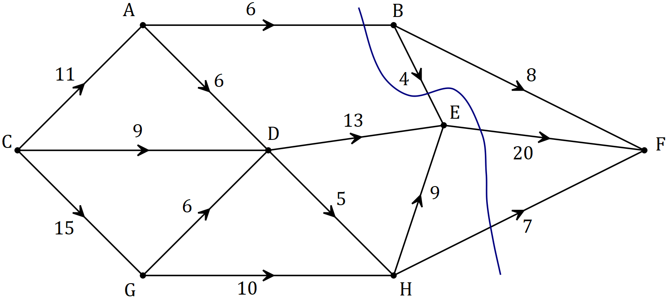

(a) By listing the different paths and their corresponding flow rates, determine the maximum number of people that can walk through the network from to every minute. (4 marks)

|  |
| --- |
| **Solution** |
| CABF = 6  CADEF = 5  CDEF = 8  CDHEF = 1  CGDHEF = 4  CGHEF = 2  CGHF = 7  Total flow = 33, hence maximum of 3 300 people per minute. |
| **Specific behaviours** |
| ✓ correctly shows at least two paths with flow contributions  ✓ correctly shows all paths with flow contributions  ✓ correct total flow  ✓ correctly states the maximum flow in people per minute |

(b) Verify your answer from part (a) by showing the minimum cut on the network above and showing in the space below how to determine the capacity of the cut. (2 marks)

|  |
| --- |
| **Solution** |
| See graph. NB Flow is reversed.  Capacity of cut: |
| **Specific behaviours** |
| ✓ cut clearly shown on graph  ✓ correct values used to obtain capacity |

Question 12 (9 marks)

At the start of January an annuity was set up with a sum of . At the end of each month, interest on the balance at the start of the month was added and then was withdrawn. The table below illustrates this process.

|  |  |  |  |  |
| --- | --- | --- | --- | --- |
| Month, | Balance at start of month, | Interest for month | Withdrawal | Balance at end of month, |
|  |  |  |  |  |
|  |  |  |  |  |
|  |  |  |  |  |
|  |  |  |  |  |
|  |  |  |  |  |
|  |  |  |  |  |

(a) Show how to use values from the table to deduce that the annual interest rate is .

(2 marks)

|  |
| --- |
| **Solution** |
| Monthly rate:  Annual rate as %: |
| **Specific behaviours** |
| ✓ shows monthly rate calculation  ✓ shows conversion to annual rate calculation |

(b) The linear recurrence relation for the balance of the annuity at the start of month has the form . State the values of , and . (2 marks)

|  |
| --- |
| **Solution** |
|  |
| **Specific behaviours** |
| ✓ value of  ✓ values of and |

(c) Determine the values of and in the table. (2 marks)

|  |
| --- |
| **Solution** |
|  |
| **Specific behaviours** |
| ✓ value of  ✓ value of |

(d) Determine the balance of the annuity at the end of month and calculate the total interest that the annuity has earned over the first months. (3 marks)

|  |
| --- |
| **Solution** |
|  |
| **Specific behaviours** |
| ✓ correct balance  ✓ calculates total withdrawals  ✓ correct total interest |

Question 13 (11 marks)

To investigate the hypothesis that the mass of sugar, grams, that will dissolve in ml of water changes with the temperature, , of the water, a student collected the results shown in the table below.

|  |  |  |  |  |  |  |  |  |  |
| --- | --- | --- | --- | --- | --- | --- | --- | --- | --- |
|  |  |  |  |  |  |  |  |  |  |
|  |  |  |  |  |  |  |  |  |  |

(a) Identify the explanatory variable in this investigation. (1 mark)

|  |
| --- |
| **Solution** |
| Temperature |
| **Specific behaviours** |
| ✓ correct variable |

(b) Calculate the correlation coefficient between temperature and mass of dissolved sugar and hence describe the direction and strength of the association between the variables.

(2 marks)

|  |
| --- |
| **Solution** |
| Association is strong and positive. |
| **Specific behaviours** |
| ✓ value to at least 2dp  ✓ direction and strength |

(c) Determine the equation of the least-squares line for predicting from . (2 marks)

|  |
| --- |
| **Solution** |
|  |
| **Specific behaviours** |
| ✓ gradient  ✓ -intercept |

(d) Interpret, in context, the value of

(i) the -intercept of the least-squares line in (c). (1 mark)

|  |
| --- |
| **Solution** |
| is the mass of sugar that will dissolve when the temperature of the water is . |
| **Specific behaviours** |
| ✓ correct interpretation |

(ii) the gradient of the least-squares line in (c). (1 mark)

|  |
| --- |
| **Solution** |
| For every increase in water temperature, an extra grams of sugar will dissolve. |
| **Specific behaviours** |
| ✓ correct interpretation |

(e) Predict the mass of sugar that will dissolve in ml of water at a temperature of

(i) . (1 mark)

|  |
| --- |
| **Solution** |
|  |
| **Specific behaviours** |
| ✓ correct value |

(ii) . (1 mark)

|  |
| --- |
| **Solution** |
|  |
| **Specific behaviours** |
| ✓ correct value |

(f) Comment on the reliability of both predictions in (e). (2 marks)

|  |
| --- |
| **Solution** |
| The first prediction for , is very reliable due to strong correlation and interpolation.  However, the second prediction for involves considerable extrapolation and should be treated with caution. |
| **Specific behaviours** |
| ✓ rates first as reliable with reasoning  ✓ rates second as unreliable with reasoning |

Question 14 (11 marks)

Aya deposits a fixed sum in her bank account each week so that its balance after deposits is given by , where , .

(a) Determine

(i) the balance of Aya's account after deposits. (1 mark)

|  |
| --- |
| **Solution** |
|  |
| **Specific behaviours** |
| ✓ correct amount |

(ii) the least number of deposits Aya must make so that the balance in her account exceeds . (1 mark)

|  |
| --- |
| **Solution** |
|  |
| **Specific behaviours** |
| ✓ correct number |

Starting at the same time as Aya, Bart withdraws a fixed sum from his bank account every week so that its balance after withdrawals is given by , where , .

(b) Determine

(i) the th term rule for the balance of Bart's account after withdrawals. (2 marks)

|  |
| --- |
| **Solution** |
|  |
| **Specific behaviours** |
| ✓ correct form; value of first term  ✓ correctly shows multiplied by |

(ii) the maximum number of withdrawals Bart can make until he has no money left.

(1 mark)

|  |
| --- |
| **Solution** |
|  |
| **Specific behaviours** |
| ✓ correct number |

(c) Determine the value of so that and state the value of at this time. (2 marks)

|  |
| --- |
| **Solution** |
|  |
| **Specific behaviours** |
| ✓ correct value of  ✓ correct value of |

(d) Let be the combined balance, in dollars, that Aya and Bart have in their accounts after they have made deposits and withdrawals respectively.

(i) Show that . (1 mark)

|  |
| --- |
| **Solution** |
|  |
| **Specific behaviours** |
| ✓ shows values of and |

(ii) The th term rule for is . Determine the values of and . (2 marks)

|  |
| --- |
| **Solution** |
|  |
| **Specific behaviours** |
| ✓ indicates first term and common difference of sequence  ✓ correct values |

(iii) Determine the smallest value of for to exceed . (1 mark)

|  |
| --- |
| **Solution** |
|  |
| **Specific behaviours** |
| ✓ correct value |

Question 15 (8 marks)

(a) A company advertised compound interest of pa on investments of for a period of years. Calculate the total interest on the investment over this time. (2 marks)

|  |
| --- |
| **Solution** |
|  |
| **Specific behaviours** |
| ✓ indicates calculation for future value  ✓ correct interest |

(b) Savings account A offers interest of pa compounded monthly and savings account B offers interest of pa compounded quarterly. Calculate the effective interest rate for both accounts and hence decide which savings account offers the better return.

(3 marks)

|  |
| --- |
| **Solution** |
| Account A:  Account B:  Account A offers the better return. |
| **Specific behaviours** |
| ✓ EIR for A  ✓ EIR for B  ✓ indicates account giving better return |

(c) A philanthropist is considering funding scholarships to a local college. Each student in receipt of a scholarship would receive a payment of on the yearly anniversary of the creation of the fund. Determine, to the nearest , the initial sum of money that should be deposited in an account paying interest at a rate of compounded monthly to create a perpetuity to fund all scholarships. (3 marks)

|  |
| --- |
| **Solution** |
|  |
| **Specific behaviours** |
| ✓ calculates effective interest rate  ✓ calculates interest required  ✓ solves for principal |

Question 16 (8 marks)

A company recorded the distance travelled, in hundreds of km, and the amount of fuel used, litres, for the trucks in its fleet each day. The scatterplot below shows the data for one day, for which and the equation of the least-squares line is .

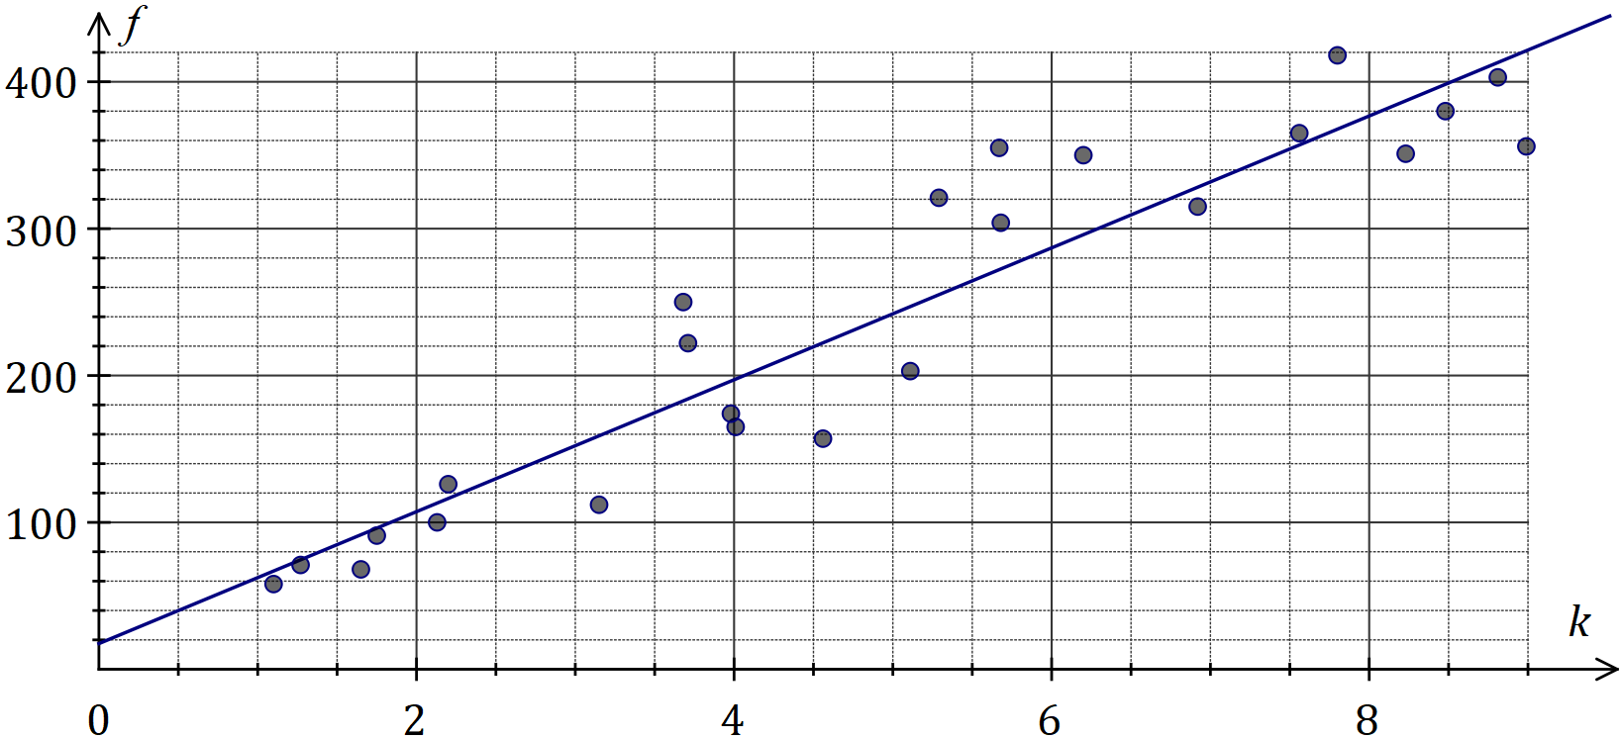

|  |
| --- |
| **Solution (b)** |
| See graph |
| **Specific behaviours** |
| ✓ reasonable straight line  ✓ close to and |

(a) What percentage of the variation in the amount of fuel used can be explained by the variation in distance travelled? (1 mark)

|  |
| --- |
| **Solution** |
|  |
| **Specific behaviours** |
| ✓ correct percentage |

(b) Draw the least-squares line on the scatterplot above. (2 marks)

(c) Determine the residual for the data point and add it to the residual plot below.

(3 marks)

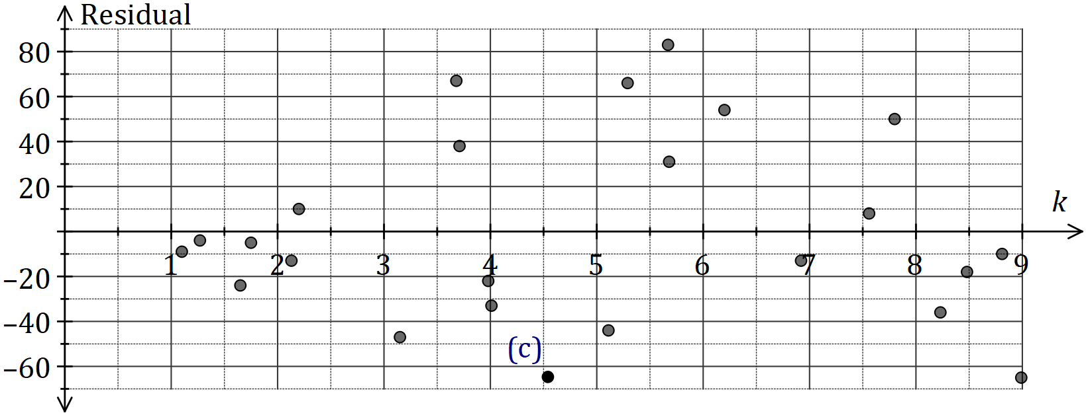

|  |
| --- |
| **Solution** |
| See graph for point |
| **Specific behaviours** |
| ✓ calculates  ✓ calculates residual  ✓ plots accurately |

(d) Use the residual plot to comment on the appropriateness of fitting a linear model to the data. (2 marks)

|  |
| --- |
| **Solution** |
| Linear model IS appropriate, as no pattern evident in the residuals. |
| **Specific behaviours** |
| ✓ indicates appropriate  ✓ supplies suitable reason |

Question 17 (10 marks)

The time, minutes, a new driver spent delivering goods on the same city route is shown in the table and graph below.

|  |  |  |  |  |  |  |
| --- | --- | --- | --- | --- | --- | --- |
| Week | Day | Day number () | Time  () | -day mean | Percentage of -day mean | Deseasonalised time () |
|  | Fri |  |  |  |  |  |
|  | Sat |  |  |  |  |  |
|  | Sun |  |  |  |  |  |
|  | Fri |  |  |  |  |  |
|  | Sat |  |  |  |  |  |
|  | Sun |  |  |  |  |  |
|  | Fri |  |  |  |  |  |
|  | Sat |  |  |  |  |  |
|  | Sun |  |  |  |  |  |
|  | Fri |  |  |  |  |  |
|  | Sat |  |  |  |  |  |
|  | Sun |  |  |  |  |  |

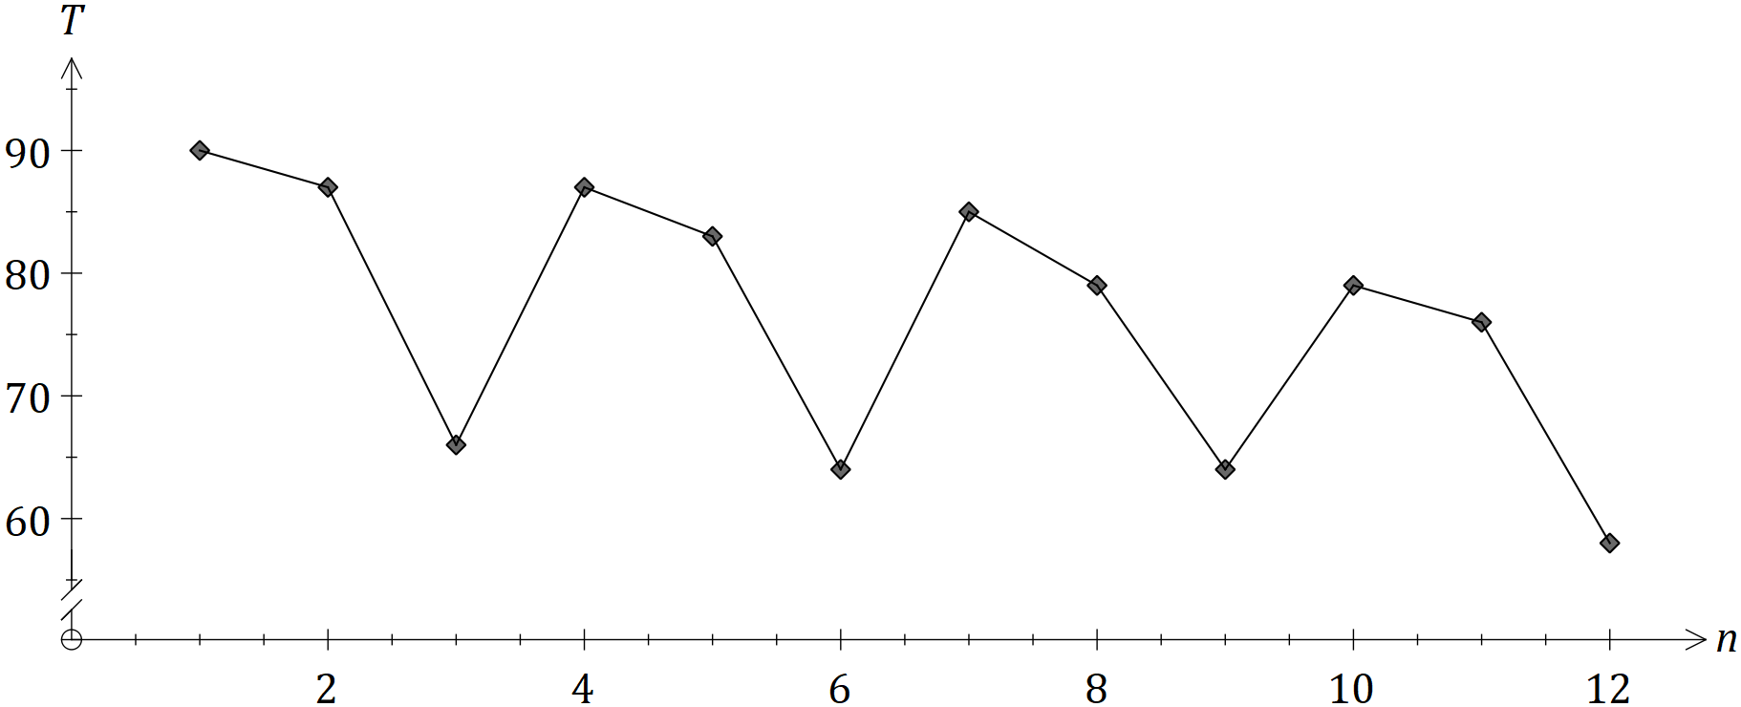

(a) Calculate the values of the entries A, B and C in the table. (3 marks)

|  |
| --- |
| **Solution** |
|  |
| **Specific behaviours** |
| ✓ value of  ✓ value of  ✓ value of |

(b) Complete the Seasonal Index table below. (2 marks)

|  |  |  |  |
| --- | --- | --- | --- |
| Day | Fri | Sat | Sun |
| Seasonal Index |  | 1.062 | 0.824 |

|  |
| --- |
| **Solution** |
|  |
| **Specific behaviours** |
| ✓ one correct index  ✓ both correct |

(c) Calculate , the deseasonalised value of for Friday of Week . (2 marks)

|  |
| --- |
| **Solution** |
|  |
| **Specific behaviours** |
| ✓ uses correct value of and index  ✓ correct value of |

The equation of the least-squares line for against is .

(d) Forecast the time that the driver will take on Friday of Week if the existing trend and seasonality continue. (3 marks)

|  |
| --- |
| **Solution** |
|  |
| **Specific behaviours** |
| ✓ correct value of  ✓ correct value of  ✓ correct forecast for |

Question 18 (7 marks)

A project requires the following activities to be completed.

|  |  |  |  |  |  |  |
| --- | --- | --- | --- | --- | --- | --- |
| Activity | Immediate predecessor(s) | Time (weeks) |  | Activity | Immediate predecessor(s) | Time (weeks) |
|  |  |  |  |  |  |  |
|  |  |  |  |  |  |  |
|  |  |  |  |  |  |  |
|  |  |  |  |  |  |  |
|  |  |  |  |  |  |  |

(a) The network below represents the interdependencies of the above activities. Clearly label each edge with its activity and time. (3 marks)

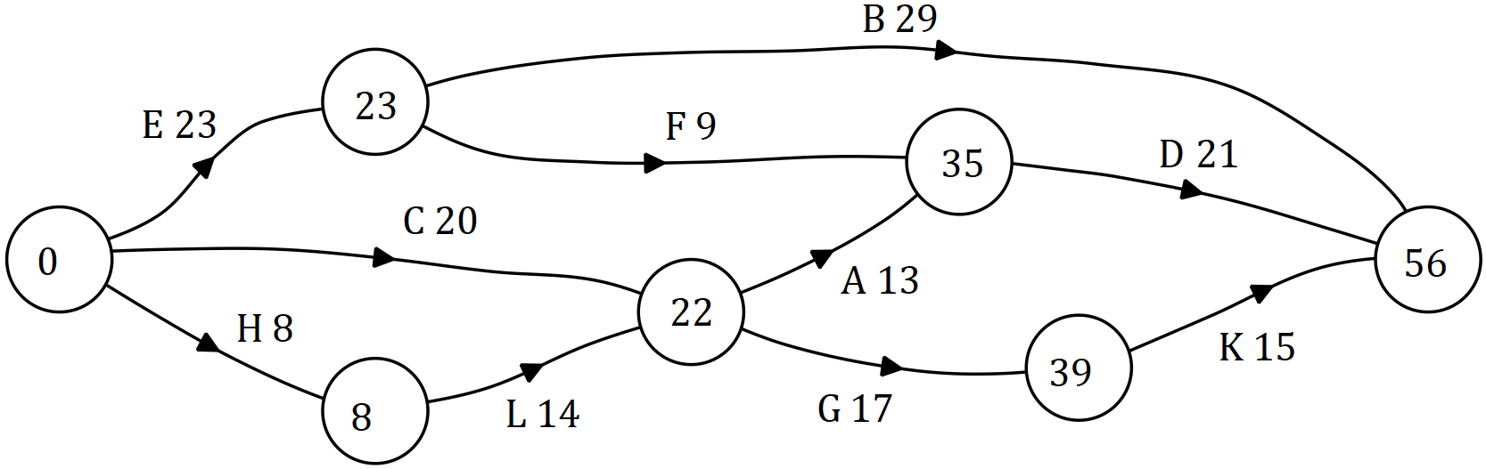

|  |
| --- |
| **Solution** |
| See graph (EST shown) |
| **Specific behaviours** |
| ✓ identifies edges  ✓ at least 7 correct labels  ✓ all labels correct |

(b) Identify the critical path and hence state the minimum time for the project to be completed. (2 marks)

|  |
| --- |
| **Solution** |
|  |
| **Specific behaviours** |
| ✓ identifies critical path  ✓ states MCT |

(c) Determine the latest start time and float time for activity . (2 marks)

|  |
| --- |
| **Solution** |
|  |
| **Specific behaviours** |
| ✓ latest start time  ✓ float time |

Question 19 (9 marks)

A business loan of was taken out at the start of the first quarter of 2018. Interest, at a rate of per annum, was calculated on the balance of the loan on the last day of each month and added to the loan. Repayments of were made on the last day of each quarter, just after interest for the month was added.

(a) Calculate the interest added during the first quarter of 2018. (3 marks)

|  |
| --- |
| **Solution** |
| Monthly rate:  After 3 months:  Total: |
| **Specific behaviours** |
| ✓ indicates monthly interest rate  ✓ indicates suitable method  ✓ correct interest |

(b) Determine

(i) the balance of the loan at the start of the second quarter of 2018. (1 mark)

|  |
| --- |
| **Solution** |
|  |
| **Specific behaviours** |
| ✓ correct balance |

(ii) the number of repayments to fully repay the loan. (1 mark)

|  |
| --- |
| **Solution** |
| Using financial calculator, |
| **Specific behaviours** |
| ✓ correct number |

(iii) the total interest charged over the life of the loan, to the nearest dollar. (2 marks)

|  |
| --- |
| **Solution** |
|  |
| **Specific behaviours** |
| ✓ indicates total repaid  ✓ correct interest (no penalty if not to nearest dollar) |

(c) The business decided to halve the loan repayments, assuming that it would take twice as long to repay the loan. Write a brief note to the business commenting on the validity of this assumption. (2 marks)

|  |
| --- |
| **Solution** |
| Assumption not true because balances owing at the end of each quarter will be greater and so there will be additional interest, taking quarters to repay the loan. |
| **Specific behaviours** |
| ✓ explanation referring to extra time because of extra interest  ✓ states actual time to repay loan |

Supplementary page

Question number: _________

Supplementary page

Question number: _________

© 2018 WA Exam Papers. Kennedy Baptist College has a non-exclusive licence to copy and communicate this document for non-commercial, educational use within the school. No other copying, communication or use is permitted without the express written permission of WA Exam Papers. SN245-126-4.